***LEVIS SHIRT508***

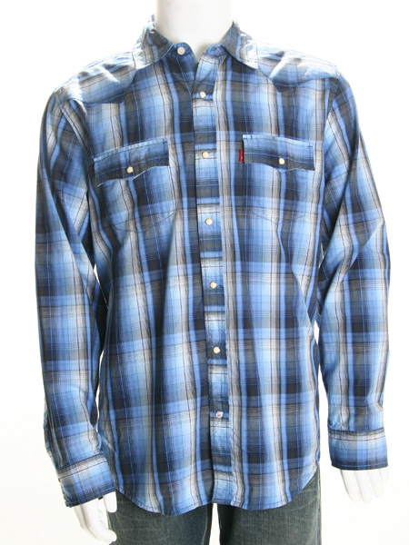

***DESCRIPTION:***

**LEVI’S SHIRT MOST VALUABLE AND BEST SELLING PRODUCT ALL OVER THE WORLD.THEY ARE LOTS OF VARIOUS COLOR AVAILABLE IN MARKETS.IT HAS VERY SOFT.THEY ARE AVAILABLE IN EVERY SIZE.**